Gowrishankar G (1BM18IS039)

Q1. DFA to accept strings having even a’s and even b’s.

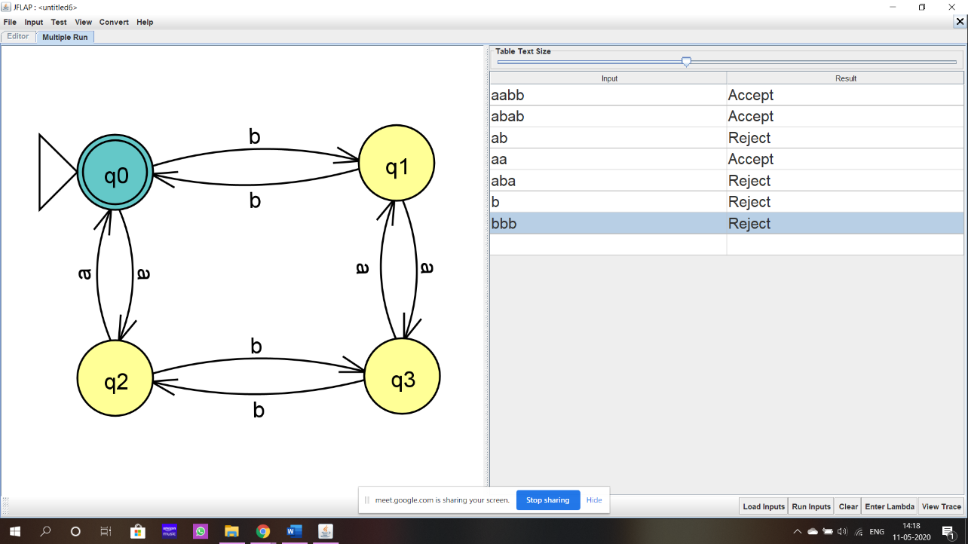

Q2. Convert DFA to minimal state DFA.

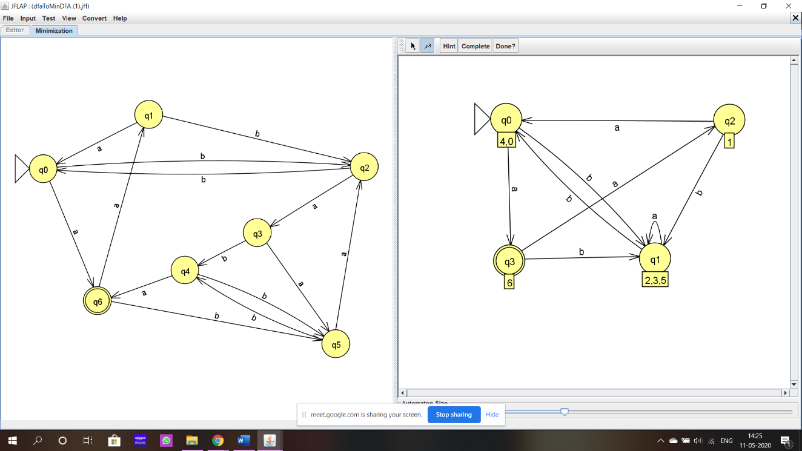

Q3. Regular expression for strings that start with ab and end with bba. Convert to nfa

Ans. ab(a+b)\*bba

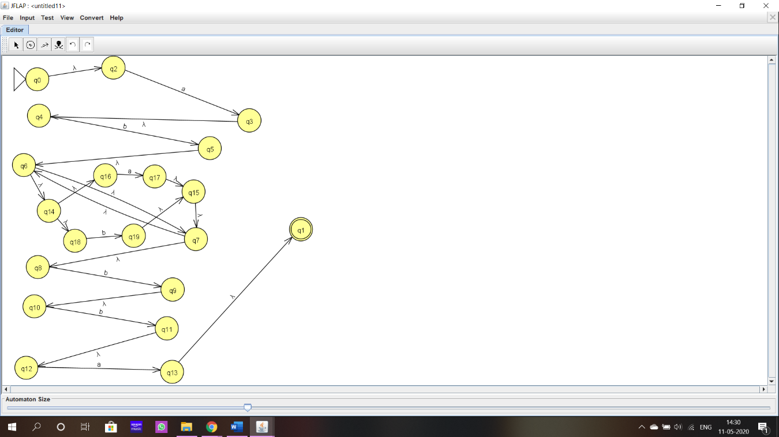

Q4. Pushdown automata for Accepting the language L={wwR| wЄ(a,b)\*}

